 

**MTaaS: Project Management**

CMPE 281 Cloud Technology

Team Project Report

Submitted to: Dr. Jerry Zeyu Gao

San Jose State University

**Team Members - Group 04**

Akshay Sonvane - 011324989

Gaurang Mhatre - 011432200

Pranjal Jain - 011427819

Shaurya Mittal - 011422736

Submitted on: 05/16/2017

**Contents**

1. **Introduction** **3**
   1. What is Smart Citizen Community? 3
   2. Main Features of Smart Community 4
2. **Smart Community Infrastructure/ Architecture 4**
   1. Deployment Oriented System Architecture 4
   2. Smart Community Components 6
      1. Messaging Component 6
      2. Social Network Cluster Component 6
      3. Social Network Modelling Component 7
3. **Technology Selection and Usage 8**
   1. Amazon Web Services (AWS) 8
   2. AngularJS, NodeJS and ExpressJS 8
   3. MongoDB 8
   4. HTML5, CSS3, BootStrap3 8
4. **Smart Community Design Diagrams 9**
   1. Use Case Diagrams 9
   2. Smart Citizen Community Class Diagram 11
5. **Implementations 11**
   1. Amazon EC2 Setup 11
   2. Load Balancer Setup 13
   3. User Interface (Design) 14
6. **Summary**
7. **References**

**1. Introduction**

**1.1. What is MTaaS?**

Aim of this project is to develop a crowd sourced testing environment for mobile applications based on a selected cloud infrastructure. The complete solution will be accessible to three types of clients. Free-lancer testers, mobile apps project manager and system administrators. These clients will be able to create and manage mobile app testing projects on cloud.

In this high-level design document, we talk about the system architecture and design for the component # 3 – Project Manager. This component will support the mobile application testing project management. Through this, project managers will have access to a cloud environment where mobile application projects can be added / updated / deleted / viewed / searched.

**1.2. Main Features of MTaaS**

* On-Demand Services
* Scalability and Multi-Tenancy
* Reliability and Security
* Easy to Use
* User Oriented

**2. MTaaS Infrastructure/ Architecture**

**2.1. Deployment Oriented System Architecture**

Here we have displayed the high level working of the MTaaS. All users and their mode of interactions are displayed. RESTful API has been used for the communication between users and the web application. In the below diagram, you can see how connection and communication are happening among different clusters and this all are managed by central management server and supplemented by load balancers. This kind of architecture is very dynamic and scalable.

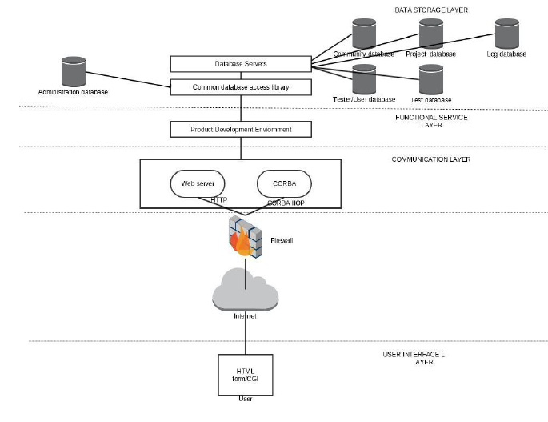

**Figure 1. High - Level MTaaA Network Architecture**

System design will be comprised of following:

1. Data Base Storage Layer: Comprising of database servers and components, all user data will be stored here. We identified database for administrator, community, project, logging and test. MongoDB will be the storage for this project.

2. Functional Service Layer: This layer will be consisting of product development environment.

3. Communication Layer: Webserver and CORBA will be the 2 pillars of communication layer.

4. Firewall: Security layer for the application.

5. User Interface Layer: UI for user interaction, which will be on HTML/AngularJS. Project managers will be interacting through this UI for all operations related to project management.

**2.2. Smart Community Components**

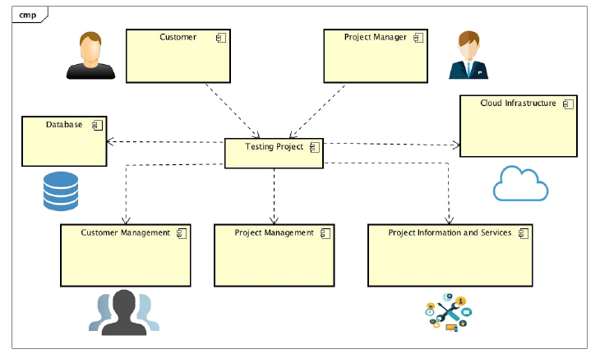

**Figure 5. MTaaS Component Design**

**2.2.1 Messaging Component**

Messaging Component scope includes communication between clients/ Manager / Tester of the such as one to one, one to many and many to many.

Different User’s has their own activities that they perform for communication.

* **Clients**: Authenticates and perform communication with other clients via different mode of communication. Product owners or customers can also access the system to view the progress of the application-testing phase.
* **Manager:** Controls manage and launch all required Projects. : Product managers will visit the portal to create / update / delete / monitor a mobile application-testing project. At any time, they can track the status of project or many any amendments to it. Project information will also be shared with the customers using notifications methods.
* **Testers:** Does create, update and delete on test cases.

**3. Technology Selection and Usage**

**3.1 Amazon Web Services (AWS)**

We have used Amazon web services for hosting, as AWS is leading in cloud services. We have used Amazon Elastic Compute Cloud (EC2) instances specifically to create our nodes (instances). Amazon EC2 provides an elastic web based computing technology; it provides a highly reliable, scalable and secured cloud hosting services. The main purpose of using Amazon EC2 is, it’s free and cost effective.

**3.2 AngularJS, NodeJS and ExpressJS**

**AngularJS** is highly structured framework for creating dynamic web applications. It can be used as HTML extension, provides dynamic templates, and conveys HTML’s syntax responses to application components easily. AngularJS helps to eliminate redundant codes with equivalent short nodes.

**NodeJS** is an open source and cross platform JavaScript run time environment, it is used for executing and handling server side JavaScript code. It build’s runtime on Chrome’s V8 JavaScript engine. NodeJS is lightweight as well as efficient because it uses an event driven, non-blocking I/O model and different more techniques. NodeJS packaging manager (NPM), is the largest ecosystem for open source libraries in world.

**ExpressJS** is a web application framework for NodeJS, it is also openly available. It supplements web applications with robust set of features.

**3.3 MongoDB**

MongoDB is a free and open source cross platform for document-oriented database system. MongoDB is reliable and scalable, it provides easy retrieval of records of existing data from the organized database system.

**3.4 HTML5, CSS3, BootStrap3**

**Hyper Text Markup Language (HTML)** used to create basic templates for web applications. HTML defines and manage the contents of the web application’s pages.

**Cascading Styling Sheets (CSS)** describes the templates appearance and improvise visualization.

**BootStrap** is very much popular among HTML, CSS and JavaScript to create responsive feedbacks from the web

**4. MTaaS Design Diagrams**

**4.1 Use Case Diagrams**

* Use case diagram for Project Management

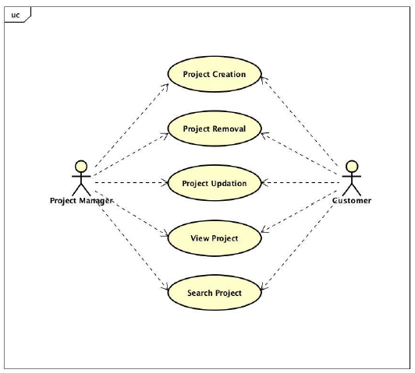

* Use case diagram for Project Information Management

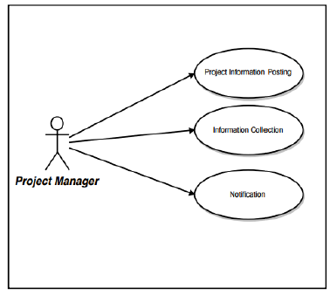

There are two users who will be using this application. Both customer and managers have almost the same access rights to the project. They can create a project, update a project, view status of a project, delete a project or search an existing project.

**4.2 MTaaS Class Diagram**

This figure explains the basic connection between the high level classes in the MTaaS web application. User class is the main class which directs and controls every other classes. Server class is connected to other classes so that it can perform its basic functionalitiesOther classes are also connected and performing their functionalities.

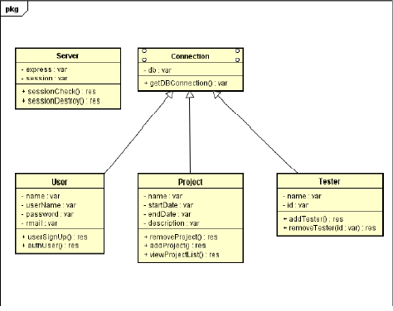

**Figure 4. MTaaS Community Class Diagram**

**5. Implementations**

**5.1 Amazon EC2 Setup**

We signed up for Amazon AWS account, and initialized Amazon EC2 instances for our different nodes which we’ll be using as services in our smart community. We selected Linux platform as our EC2 instances to run upon. We deployed ExpressJS framework on NodeJS development environment and then deployed this development in EC2 instances. We referred some contents online, on how to deploy ExpressJS on Amazon EC2.

http://docs.aws.amazon.com/AWSEC2/latest/UserGuide/get-set-up-for-amazon-ec2.html

<http://docs.aws.amazon.com/elasticbeanstalk/latest/dg/create_deploy_nodejs_express.html>

Screenshot of our Amazon EC2 instance

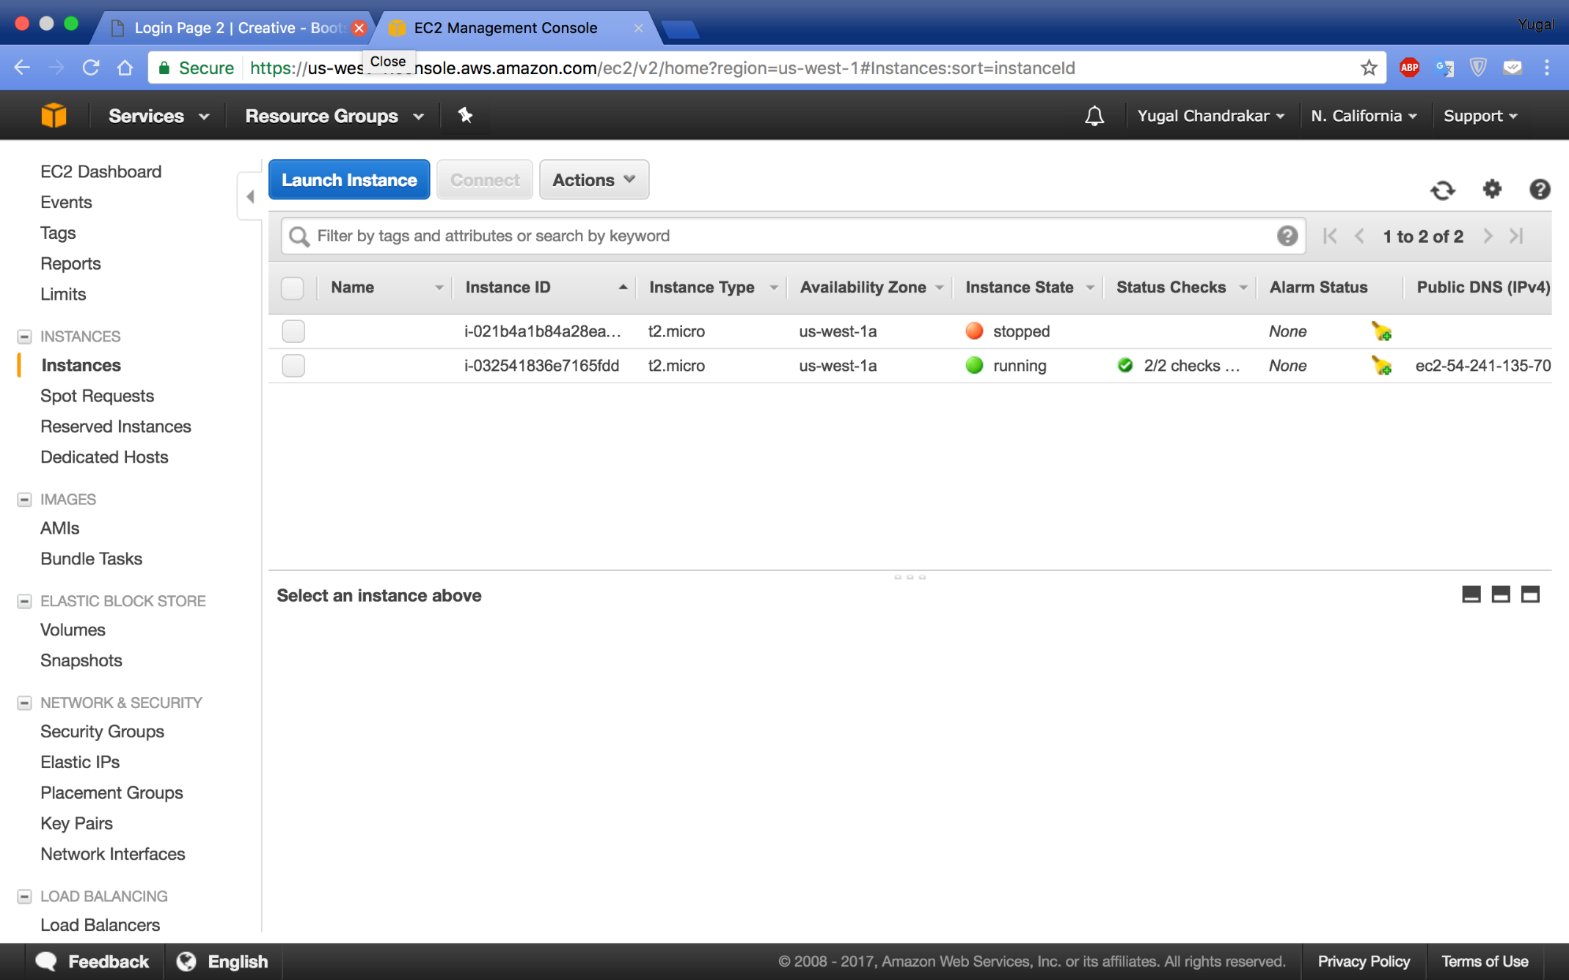

**Figure 7. Amazon EC2 instance**

Following figures displays the Amazon Cloudwatch of EC2 instances. Here we’re monitoring the virtual machines usage. Particularly of metrics namely “Network Packets In” and “Network Packets Out” of a EC2 instance.

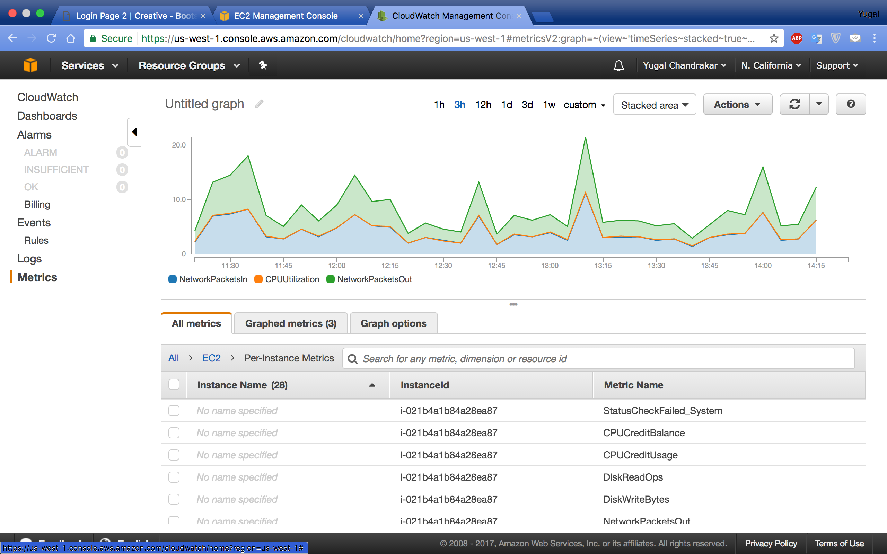

**Figure 8. Amazon CloudWatch monitor of EC2 instance**

**5.2 Load Balancer Setup**

To execute the process in CPU, we’re using round robin algorithm as scheduling algorithm. In round robin, we use time sharing systems. Round robin is similar to first come first serve, it also has some additional features like preemption functionality for switch between the processes. The task distribution is divided equally among other processes, it works on request based on priority queue method. Load balancer divides and manage incoming traffic to multiple EC2 instances according to availability zones. We can monitor all EC2 instances, which is exhausting too much and which is free most of the time, then balance the traffic accordingly.

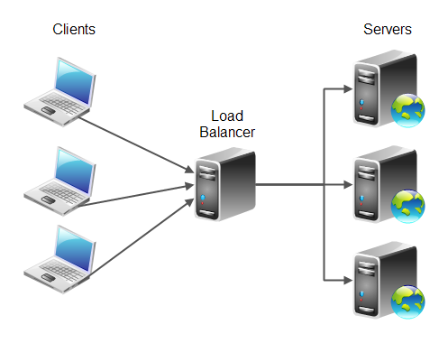

**Figure 9. Typical Load Balancer**

Listener authenticates the connection requests. Listener is configured with front end ports and protocol 8080 and back end port with protocols (Load balancer to instance). Here we accept HTTP requests on port 8080 and send them to identified instances with using port 8080 on HTTP.

Running Amazon EC2 instance with Load balancer:

**5.3 User interface**

Smart citizen community has three kind of users “Citizen”, “Moderator” and “Admin”. All users perform different kind of functions assigned to them. Admin has the full access to all of the community. Moderator has the access to create and manage a cluster of assigned service oriented social community network. Community citizens has the access to use all available services availed by their respective community. Each citizen has to register before using this services, they may choose their assigned community. Citizens has the ability to subscribe or unsubscribe availed services by a community.

**Citizen Login**

The web app is running over the server with the help of NodeJS and EC2 instance over the server address of <http://54.242.91.24:3000/>. This is the functionality a normal citizen can perform over our application. This the process a new citizen would follow when they moved to a new community and wanted to use communities available cloud services.

* The Login Page

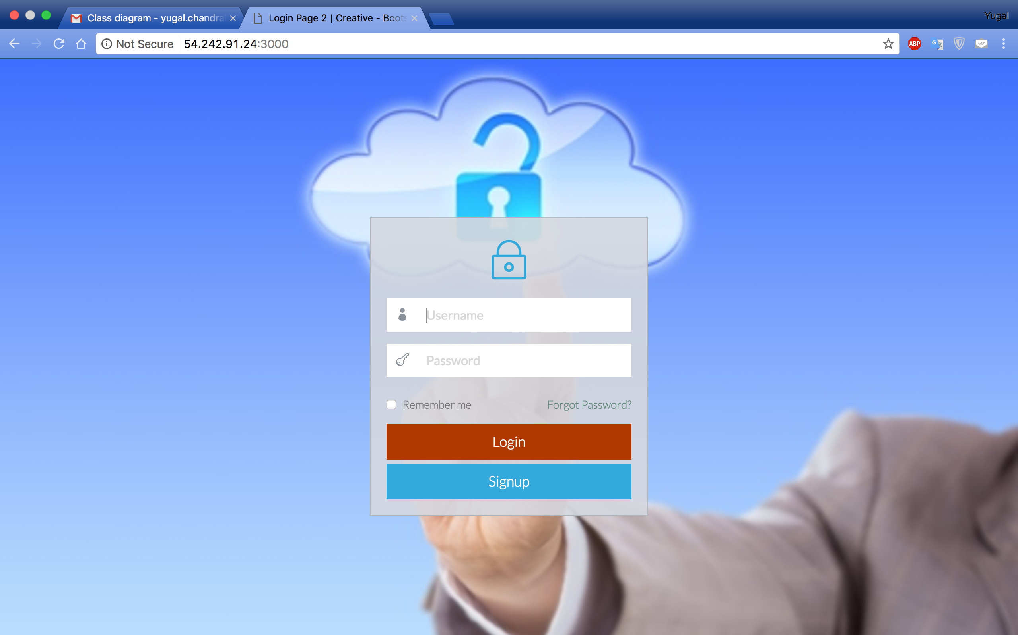

* Signup Page

As new user won’t be having username and password from him/her. They have to signup themselves first so that system will generate a new citizen account for them.

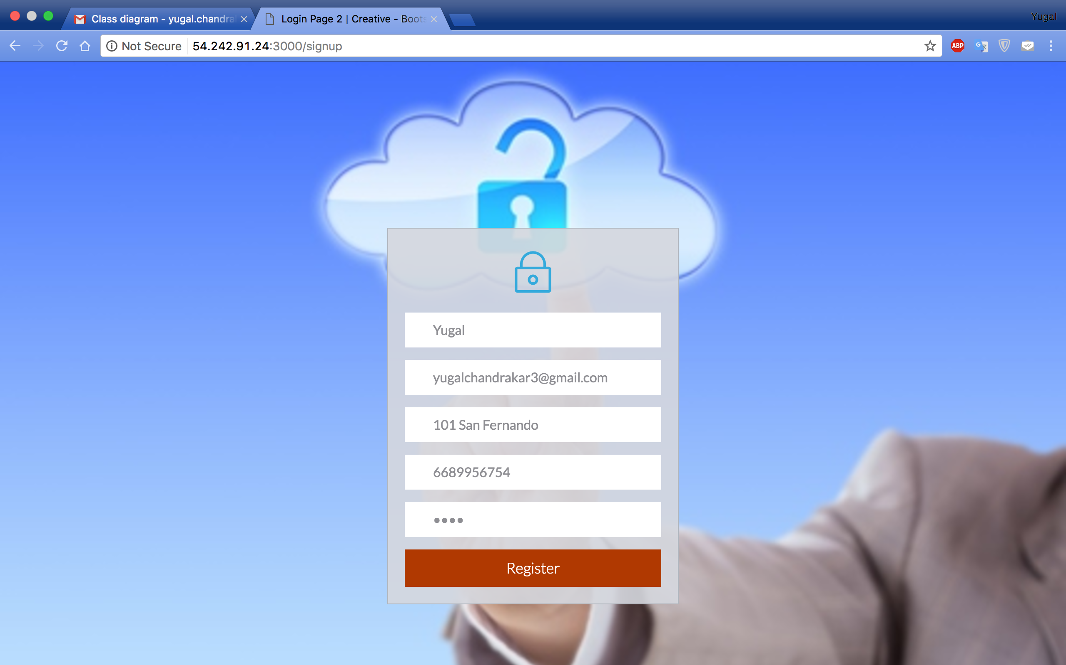

* Community Selection Page

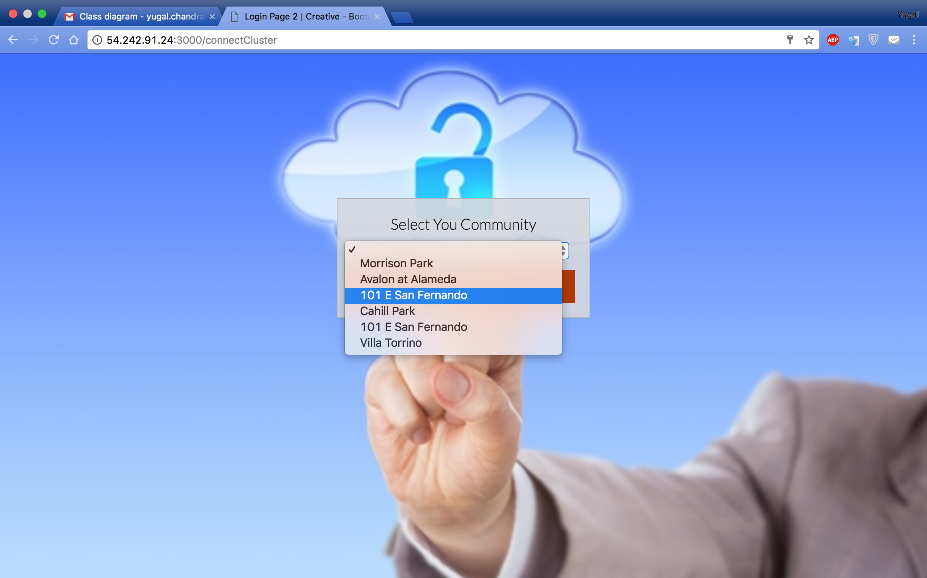

After successful signup, system prompts citizen to select their specific community. Where they’ll be going to live.

* User Dashboard

After selecting the desired community, citizen account will be created and citizen will be added to the community network. The user will be by default subscribed to the available services by their respective community. Like here two services are already assigned to the user named **crime alert** and **event services**.

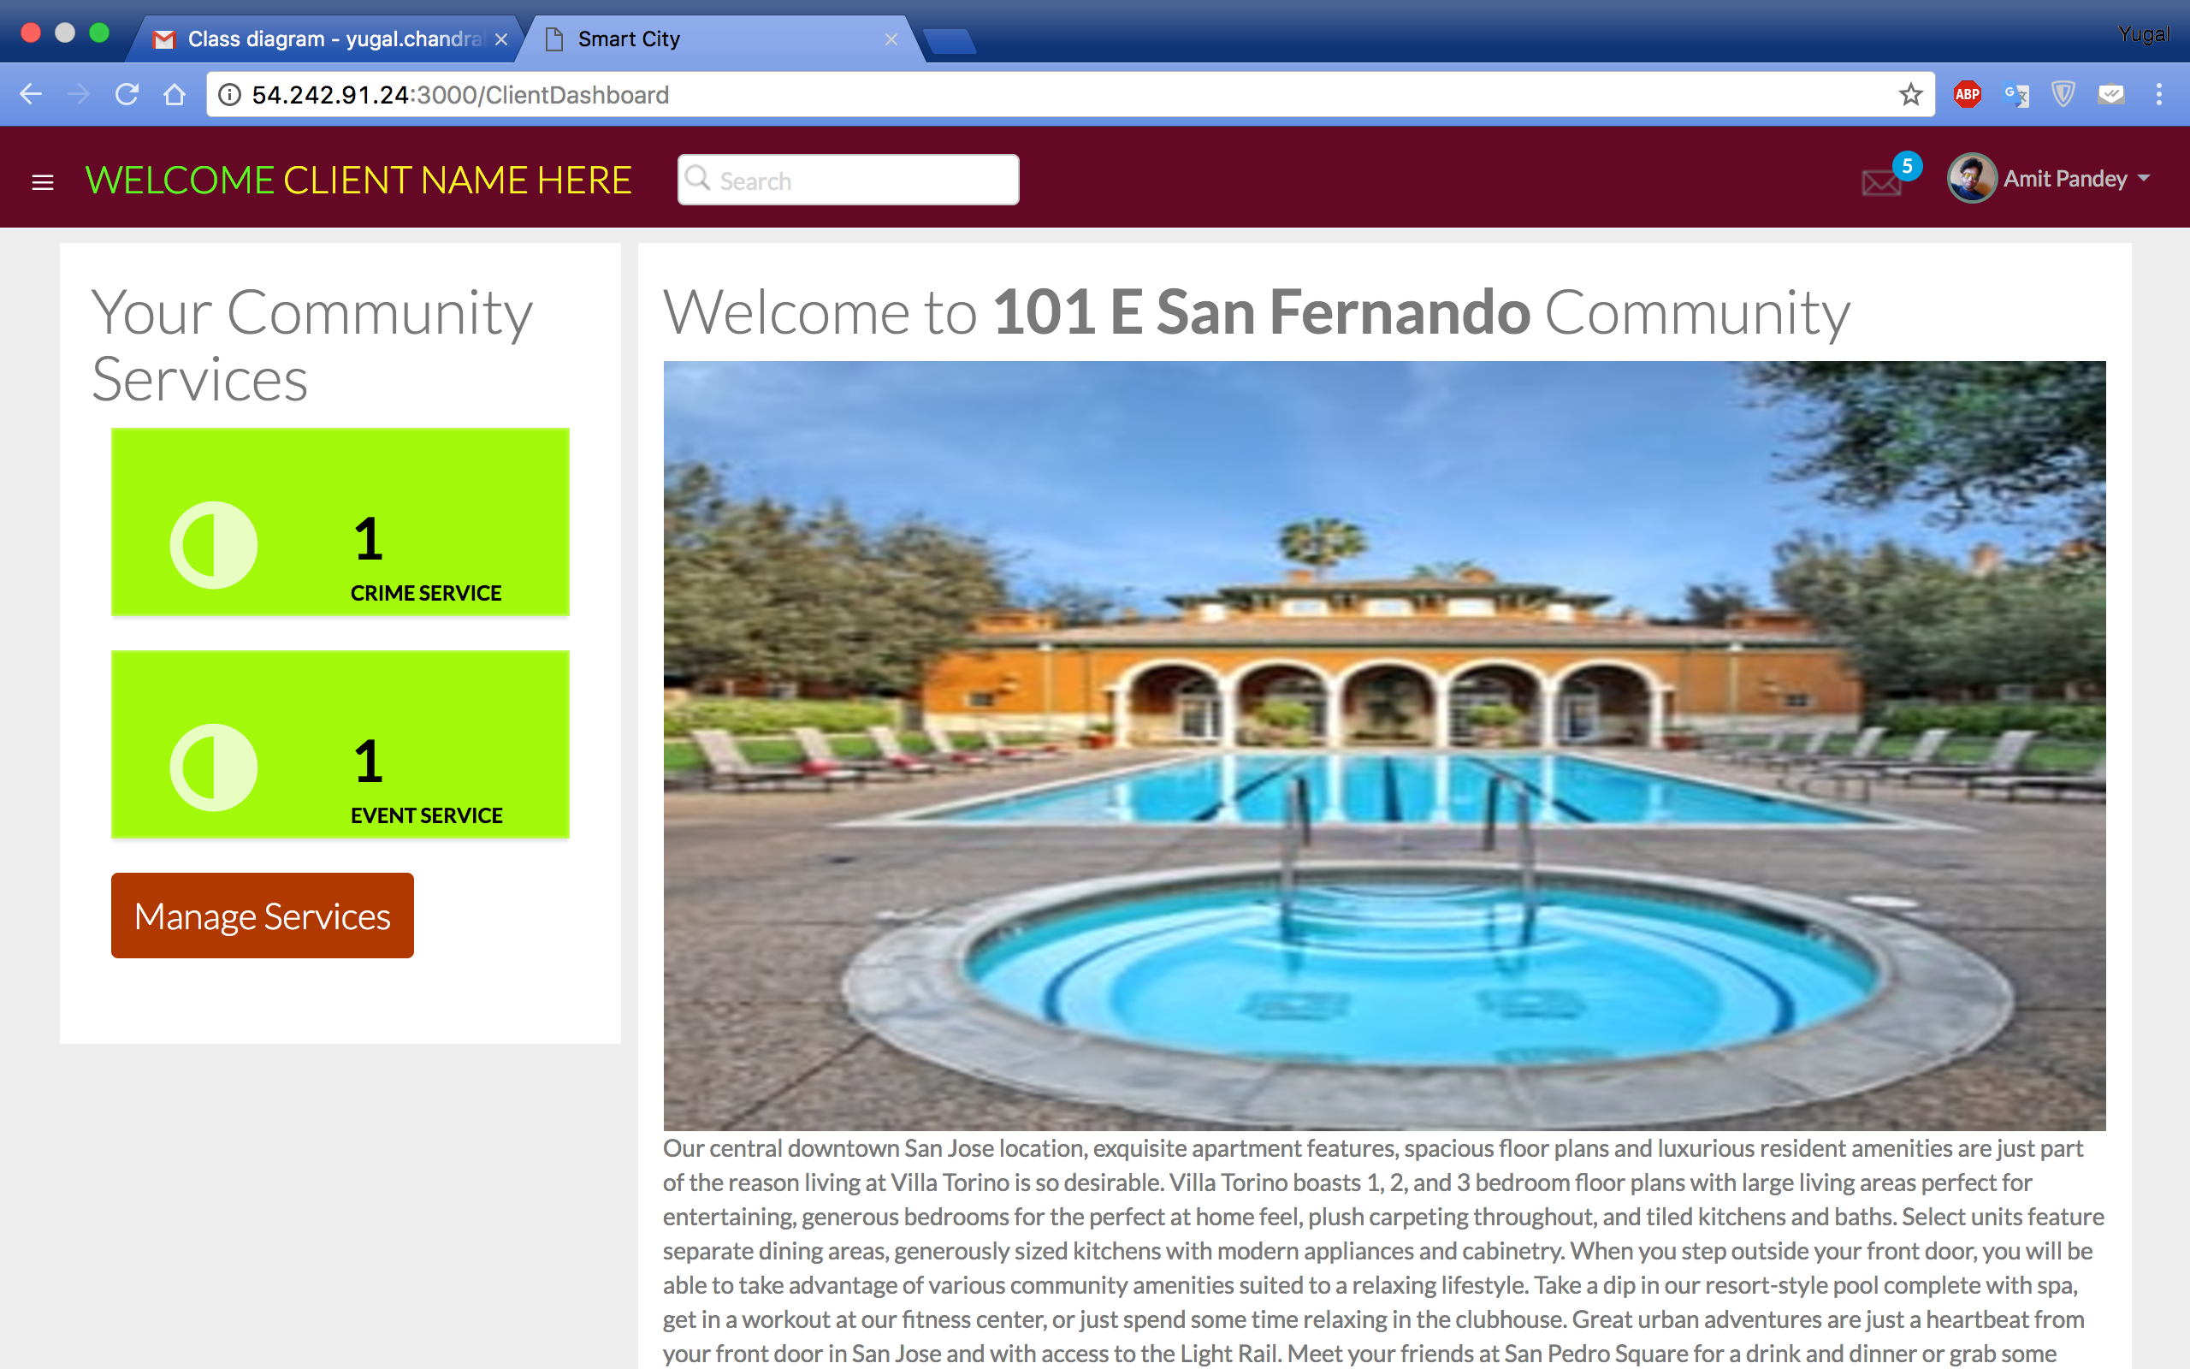

* Services

As user wants to use the available services, when he clicks for a services page shows the available prior information by the community and other information posted by other citizens. User will be given opportunity to post new events or crime alert by the web application.

Crime alert Service

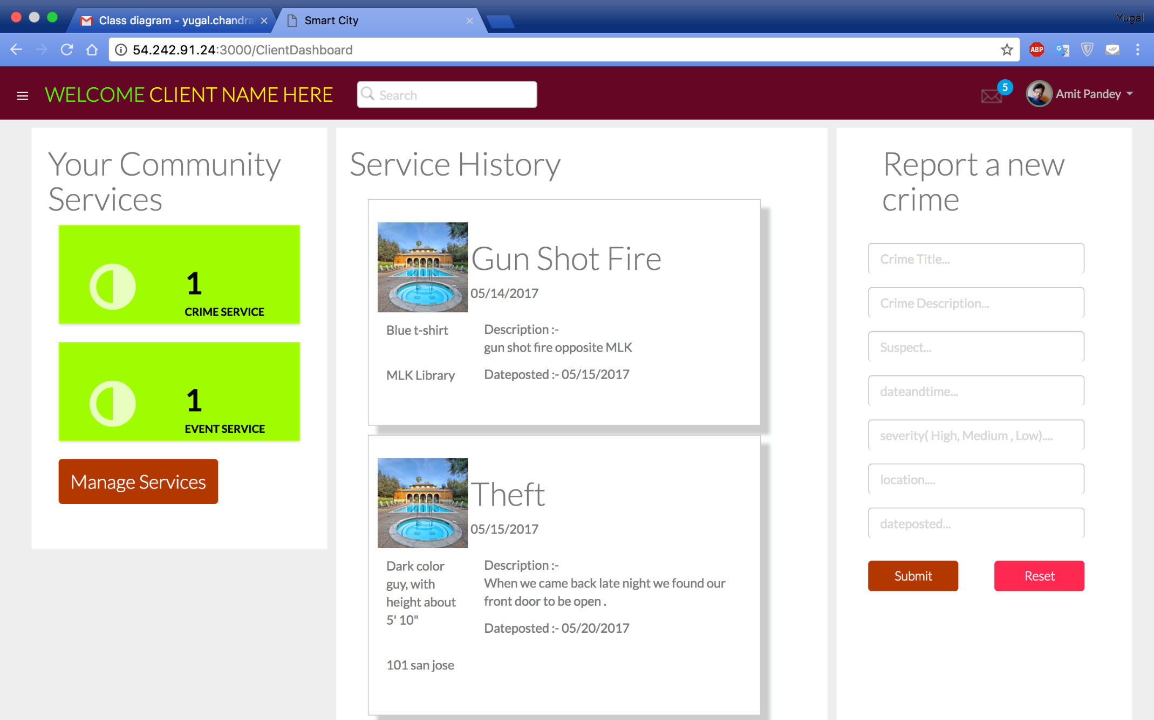

Event Service

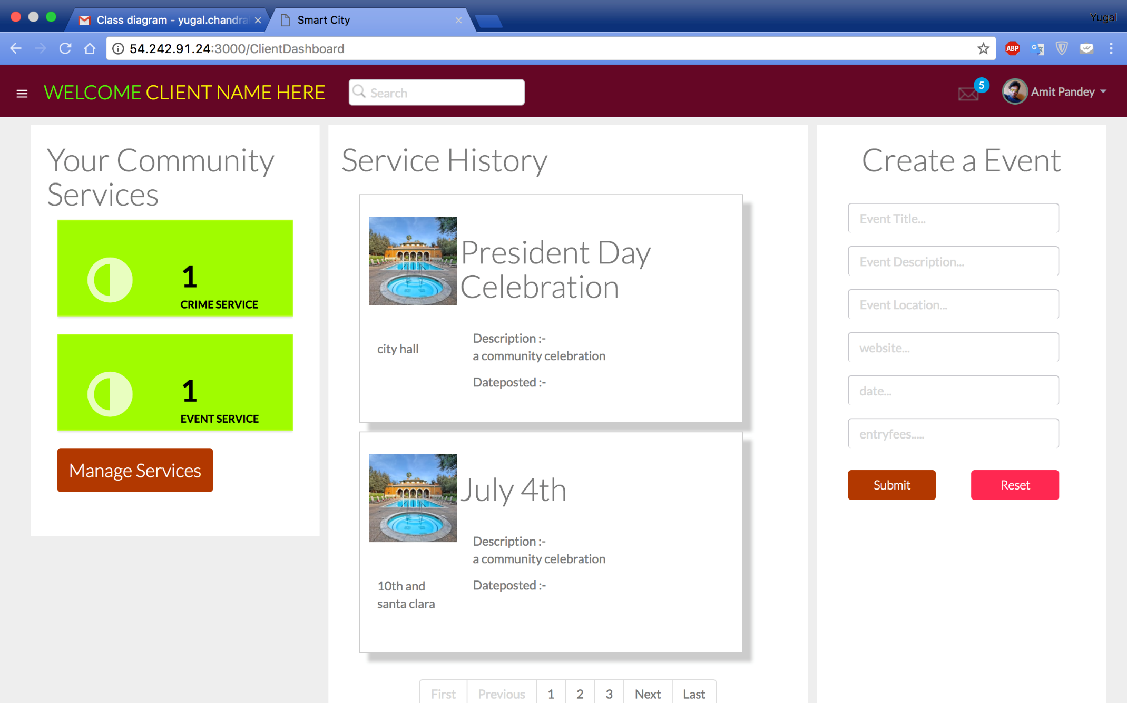

* Manage Services

A citizen can manage its services by unsubscribing a existing service and subscribing to a new available service to its dashboard. After subscription of a new service, user can avail its features over their dashboard itself. If a citizen unsubscribes a particular service, then he won’t be getting notifications from that service and that service will be removed from the that particular citizen’s dashboard.

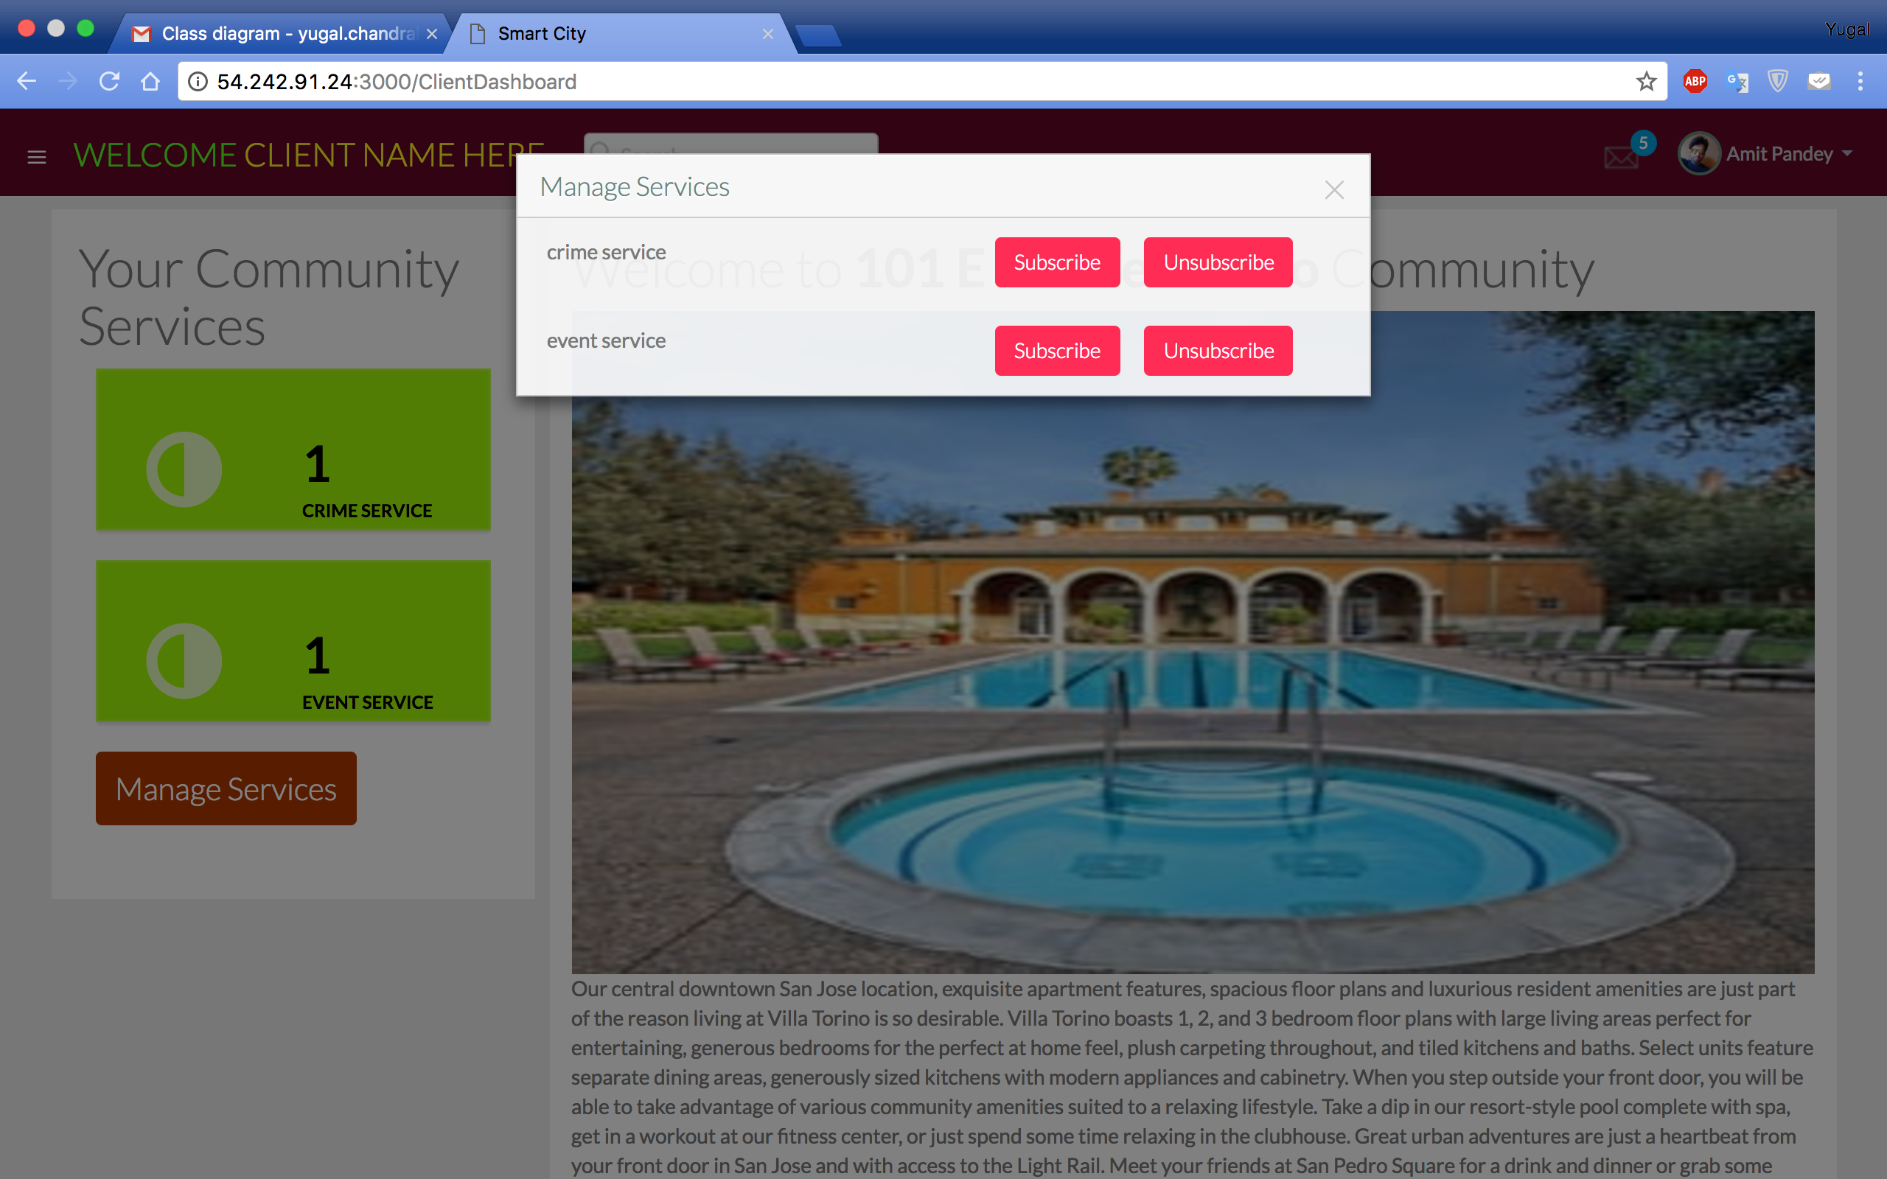

* Messaging Component

We have implemented a messaging component in this web application. A citizen has a feature to talk with their other community members via one to many communication protocol and one to one messaging between user and admin of the system.

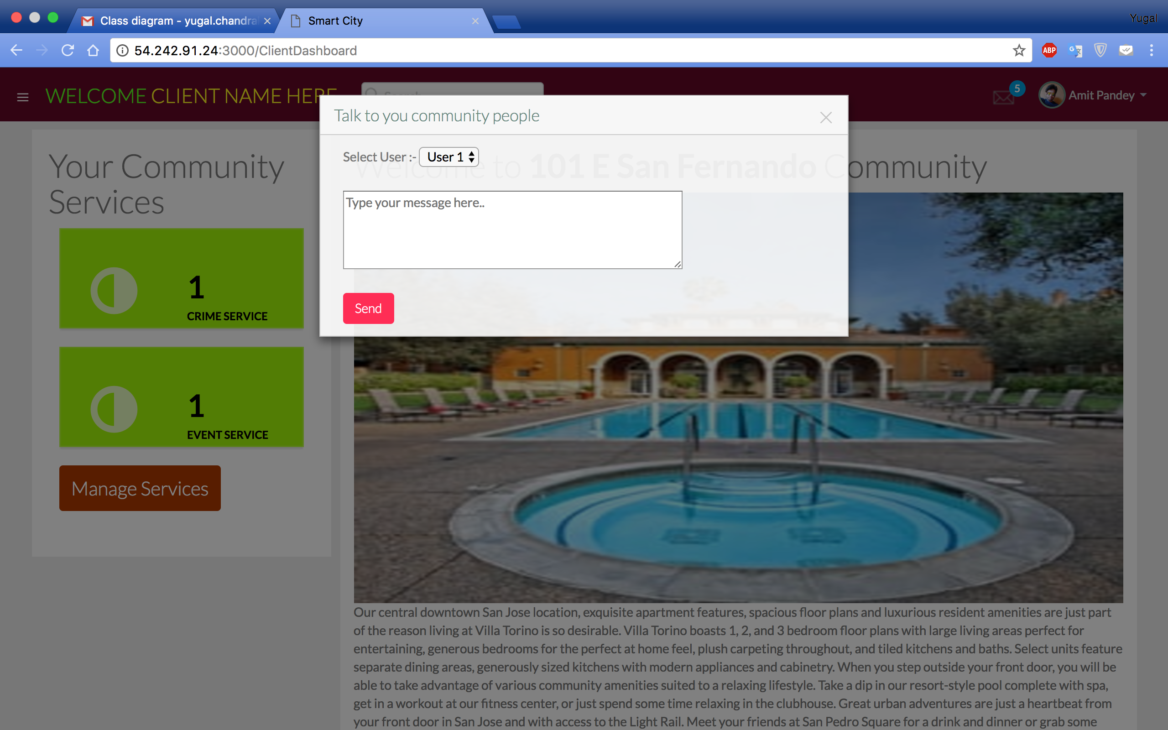

The messages which are posted earlier will be display like this.

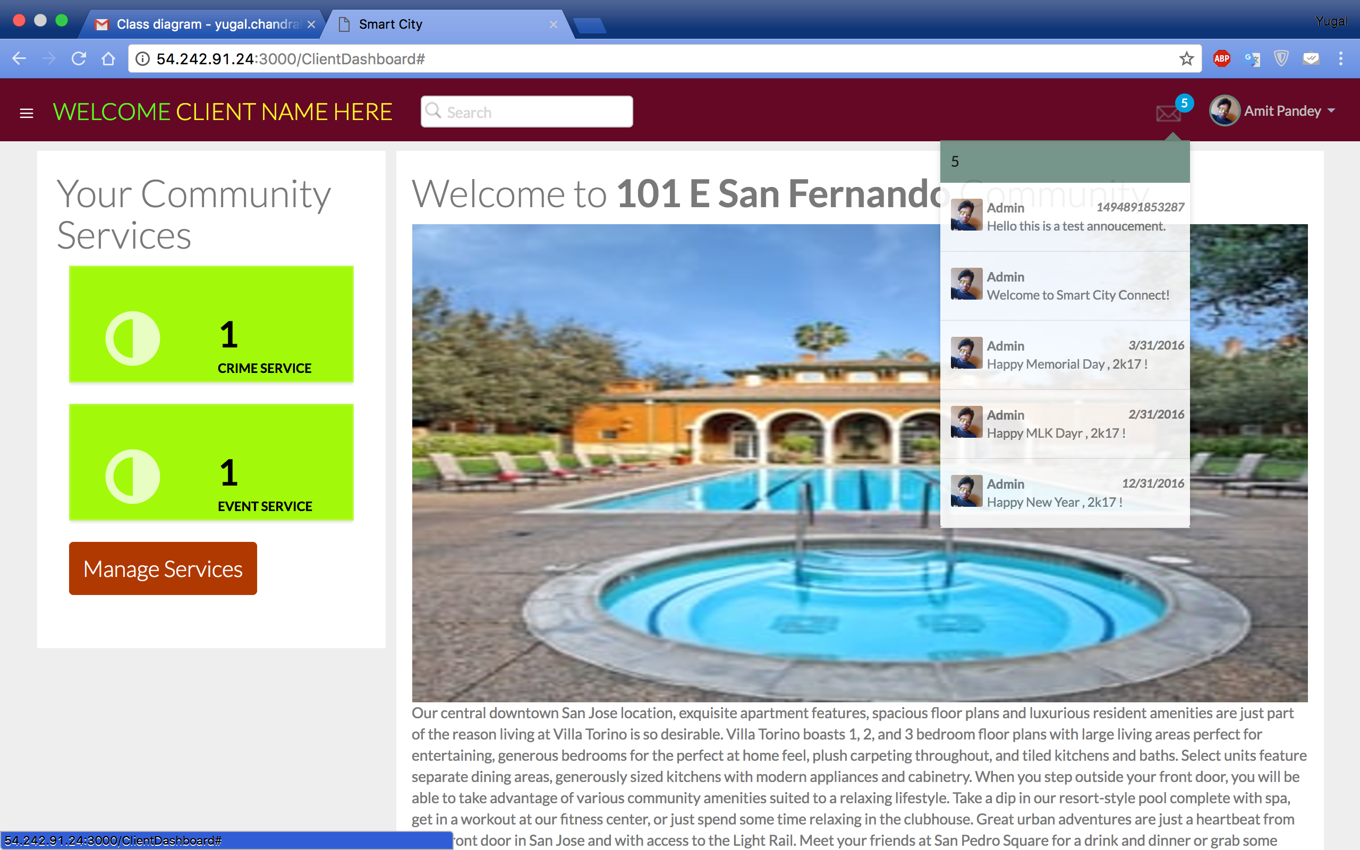

**Admin Login**

**6. Summary**

MTaaS is a crowd sourcing testing environment for mobile applications based on a

Selected cloud infrastructure, which reflects the future Testing characteristics. This Platform is administered by system administrators and Managers for un-interrupting functioning and utilized by Clients and Testers. This platform provides various kind of services like adding new projects, Assigning new users to the project, add test cases, Broadcast message. These services are used by testers and clients and can be managed by managers. Admins can perform CRUD operations on Projects, test cases and additional.

**7. References**

* <https://aws.amazon.com/>
* [https://aws.amazon.com/ec2/](https://aws.amazon.com/rds/)
* <http://www.w3schools.com/jquery/>
* <https://aws.amazon.com/cloudwatch>
* <https://www.tutorialspoint.com/cloud_computing/cloud_computing_mobile.html>
* <http://expressjs.com>
* <https://www.mongodb.com/>
* <http://expressjs.com>
* <http://angularjs.com>
* <https://nodejs.org/>